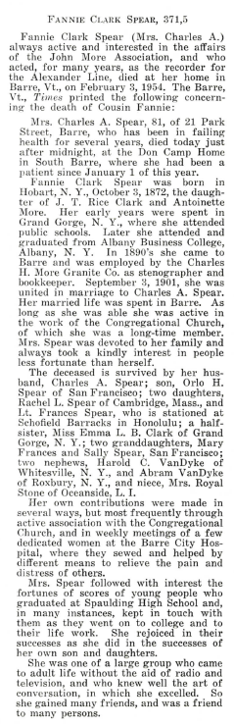
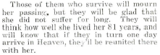
Pages 497-498
1955 November issue The Historical Journal of the More Family

